DEE Library
Welcome to the Department Library, this is one of the support services of our department of education & extension. The mission of the DEE Library is: To provide information services and access to full text and bibliographic electronics, digital and printed resources to support the scholarly and informational needs of the department community. The DEE Library is a hub of knowledge with an enviable collection of international & national books, Psychological Test, Print Journals, Periodicals, e-Journals online/offline e-Books, Question Papers and Syllabus, P. hD, M. Phil Thesis CD/DVD, and Videos based teaching material etc The library uses Koha Library Management Software.
The library has more than 13926 books with subscription to 5000 plus online e-journals and 2 print journals. Students have open access in the library with extended hours of working in department time with unlimited Internet access specially provided in Digital library.
The department of education & extension are one of the best in the SPPU Campus single discipline department library includes so many books of science, education, research, interdisciplinary research, ICT books, psychological test and journals and newspaper and employment news, etc.
The department library is providing so many services and facilities for students and faculty. The DEE library is providing quality education keeping the knowledge update and currant updated knowledge. Koha software are two major part of functioning for work. 1) Koha software & 2) Koha OPAC
- Koha Software: Following modules are functioning in Koha software.
Circulation, Cataloguing Serials, Reports, Tools, About Koha, Patrons, Advanced Search, Lists.
- OPAC (Online Public Access Catalog): An Online Public Access Catalog is an online bibliography of a library collection that is available to the public.
Koha OPAC Link http://deptlib.unipune.ac.in:8001/
Vision: To create professional and overall development through education.

Integrated Library Management System (ILMS)
- Koha Software: We have implemented integrated library management system software partially. Koha software is free software/open-source Software. This software was provided to our department through Savitribai Pule Pune University. Koha has been uploaded and after data feeding in it, the OPAC (Online Public Access Catalogue) facility will be available for everyone.
- Koha Software Link: http://deptlib.unipune.ac.in:8000/index.html
Above link start form dt. 11/11/2022
Total No. of books 6227 uploaded in Koha software and other under process.

- TECHNICAL ACTIVITIES:
- Acquisition : Books are purchased as per the requirement of the readers
- Accessioning : Acquired books are entered in the Accession Register & Koha Software
- Classification : Books are classified with Dewey Decimal Classification Schedule.
- Cataloguing : AACR-II & Koha Software are used for cataloguing of library collection.
- Book Preparation: Sticking of tags, preparing book cards, stamping
- Book Keeping : Books are kept subject wise.

- Library Services and Facilities:
- Reference Service
- Book Bank Service
- Inter Library Loan Service
- Internet Facility
- Reading Room Facility
- Suggestion Cum Complaint Box
- digital facilities. (Studies materials send to what’s App Group)
- Open Access for all Students, Staff & Visitors: Access to online journals under E-ShodhSindhu program and journals and databases subscribed by Jayakar Library.
The DEE library is optimally used by the faculty and students.
e-resources: Jayakar Knowledge Resource Centre, Savitribai Phule Pune University, Pune.
Link: http://lib.unipune.ac.in:8002/ This link accessible are Jaykar Library as well as all departmental library.
      - E- journals
      - E- books
      - E- shodhsindhu
      - Shodhganga
      - Databases
All these Resources are available in university’s main Jaykar Library.
DDE Library Information
a) Total Area of Library | (Sq. Met): 66.937 | (Sq.Ft.): 720.42 |  | Seating Capacity of  Reading Room
b) Reading Room | (Sq. Met): 66.937 | (Sq.Ft.) : 720.42 |  | 25
i) Total No of Text Books |  |  | 4620
ii) Total No of Reference Books |  |  | 9274
iii) Total No of Encyclopedia |  |  | 32
Total Books = |  |  | 13926
iv) Total No of Titles |  |  | 9231
v) Psychological Test |  |  | 93
vi) Thesis: (Ph.D. + M. Phil) |  |  | 443+181= 624
vii) Total No of Journals/ Periodicals |  |  | 02
viii) Total No of Educational CD/DVD.Videos |  |  | 65

Useful Links
Sr. No. | Resources | Links
1 | National Digital Library | https://ndl.iitkgp.ac.in/
2 | SWAYAM Online Courses | https://storage.googleapis.com/uniquecourses/online.html
3 | National Knowledge Network | https://nkn.gov.in/en/
4 | NPTEL (National Programme on Technlogy Enhanced Learning) | https://nptel.ac.in
5 | InfoPort | https://infoport.inflibnet.ac.in/
6 | Talks to Teacher | https://www.ted.com/playlists/182/talks from inspiring teachers
7 | A-VIEW | https://aview.in/
8 | Virtual Labs | https://www.vlab.co.in/
9 | FOSSEE | https://fossee.in/
10 | Spoken Tutorial | https://spoken-tutorial.org/
11 | E- Yantra | https://www.e-yantra.org/
12 | Oscar++ | https://www.it.iitb.ac.in/oscar/
13 | E-Kalpa | https://icar.org.in/content/e-kalpa
14 | NCERT Text Books (class1to XII) | https://ncert.nic.in/textbook/textbook/htm
15 | Directory of Open Access Books | https://doabooks.org/
16 | Directory of Open Access Journals | https://doaj.org/
17 | Open Knowledge Repository- World Bank | https://openknowledge.worldbank.org/
18 | UG/PG MOOCs | https://ugcmoocs.inflibnet.ac.in/
19 | e-PG Pathshala | https://epgp.inflibnet.ac.in
20 | e-Content Courseware in UG Subjects | https://cec.nic.in/cec/
21 | SWAYAMPRABHA | https://www.swayamprabha.gov.in/
22 | e-Shodh Sindhu | https://ess.inflibnet.ac.in
23 | Vidwan | https://vidwan.inflibnet.ac.in
24 | SNLTR | https://nltr.org/
25 | Oxford Open | https://academic.oup.com/journals/pages/open access
26 | Cambridge University Press | https://openknowledge.worldbank.org/
27 | Science Direct Open Access Content | https://www.sciencedirect.com/browse/journals-and-books?accessType=openAccess
28 | ILOSTAT | https://iloslat.ilo.org/
29 | Project Euclid | https://www.projecteuclid.org/librarians/lib oa
30 | AidData | https://www.aiddata.org/
31 | Springer Open Journals | https://iloslat.ilo.org/
32 | Taylor & Francis Open Access | https://www.projecteuclid.org/librarians/lib oa
33 | Open Access Thesis & Dissertations | https://oatd.org/
34 | Shodhganga | https://shodhganga.inflibnet.ac.in/
35 | The OAPEN Foundation | https://oapen.org/content/
36 | PubMed Central (PMC) | https://www.ncbi.nlm.nih.gov/pmc/
37 | Project Gutenberg | https://dev.gutenburg.org/
38 | High Wire | http://www.highwirepress.com/
39 | AGRIS | http://agris.fao.org/agris-search/index.do
40 | Southern Connecticut State University | https://libguides.southernct.edu/openaccess/
41 | LibriVox - Audio Books | https://librivox.org/

General rules of library
- Every student/readers should carry identity card always in DEE library.
- Every student is required to enter/write his/her name in library entry register at the entrance of the DEE library.
- Every student should his/her Membership card and should produce it on demand.
- All students will be issued 02 books at a time for 15 days. 1 book for 24 hours.
- Digital library and internet facility use is only for academic purpose not for entertainment.
- Smoking, spiting, eating are strictly prohibited in the library premises.
- Please maintain silence in the library.
- Keep your mobile switch off.
- Sleeping in the library strictly prohibited.
- The library material included books, magazines, journals, CD’s/DVD, Psychological Test, Ph.D, M. Phil Thesis, Question Papers, Syllabus and equipment should be handled with almost care. If above rules not followed penalty will be imposed.
- The library reserves the right to search any personal item and does not accept liability for loss or damage to them.
- Users/Readers belongings should be kept on the rack.
- Students/Readers shall not write on or damage the book and journals. Before leaving the counter borrower must satisfy himself / herself that the book sent is in good condition and if not must immediately bring the matter to the notice of the concerned staff, he/she is required to replace such damaged or lost book by new copy. In case this is not possible due to such book being out of print the member will be required to pay the prevailing cost of the book with additional change as determined by the Librarian subject to a maximum of 100% of the prevailing cost of the book.
- The date on which the book must be returned is stamped on the slip affixed to the book and student delaying the return is fined as per the rules of Library Committee.
- Students must inspect the book at the time of borrowing and make sure that they are complete and undamaged. At the time of issue if any damage is noticed, a student should inform the library staff. Any damage detected at the time of return of the book will be the responsibility of the student and will have to pay the penalty as well as the appropriate cost of the book or replace the book.
- In case the Identity card is lost, kindly inform to the Librarian immediately to prevent its misuse.
- Users are requested to have a cordial relationship with library staff.
- Users must submit Identity card to DEE library at the time of clearance.

Library Photo Gallery:

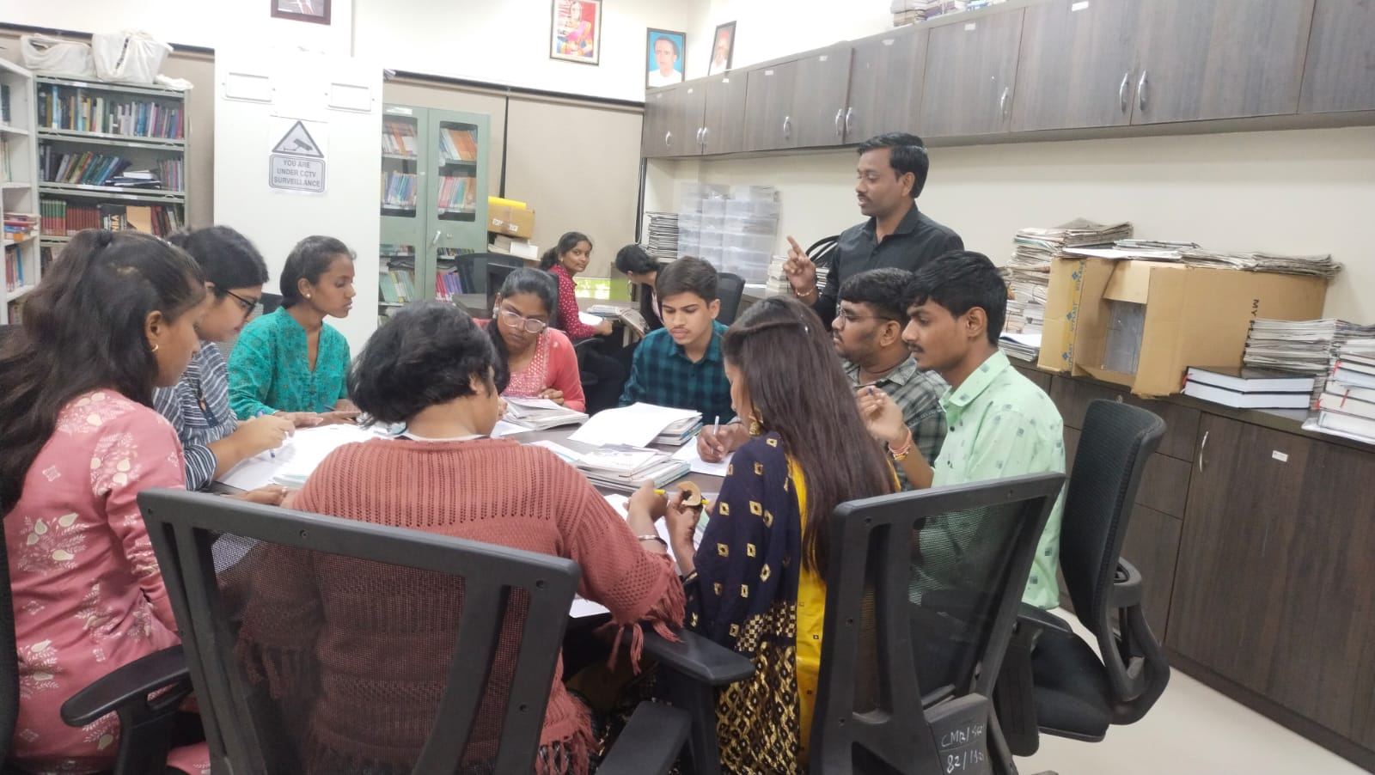
DEE Library Orientation

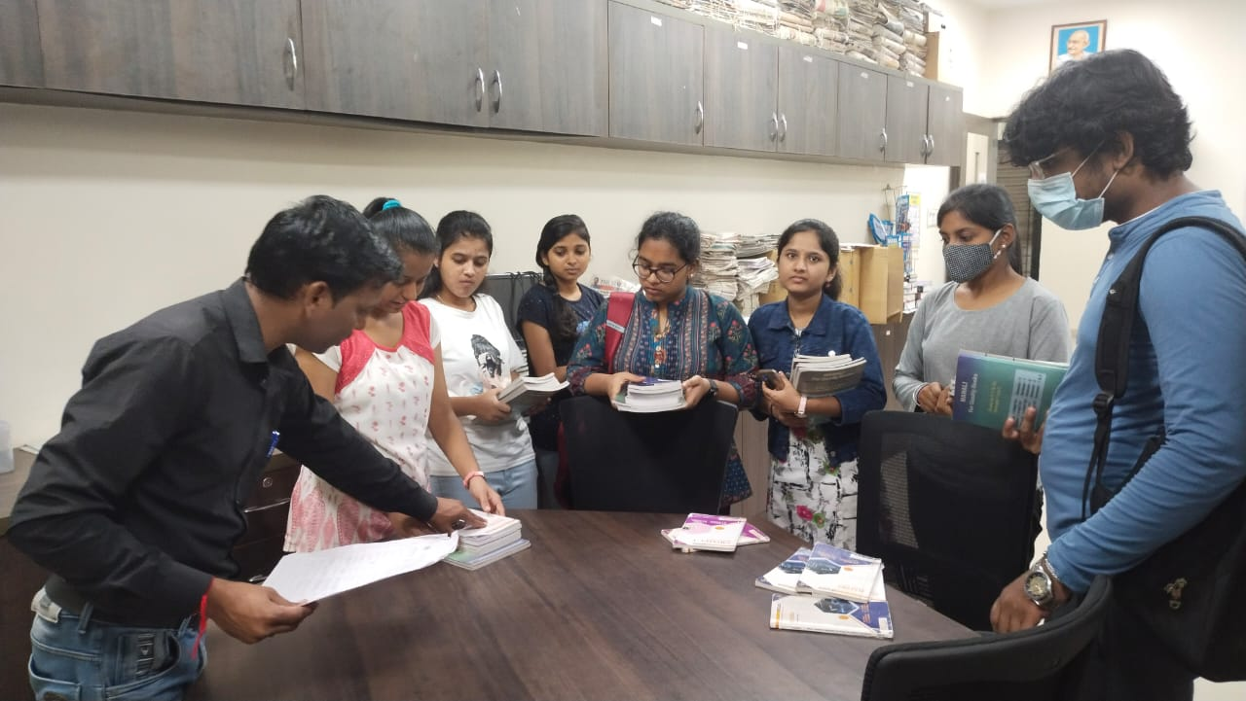
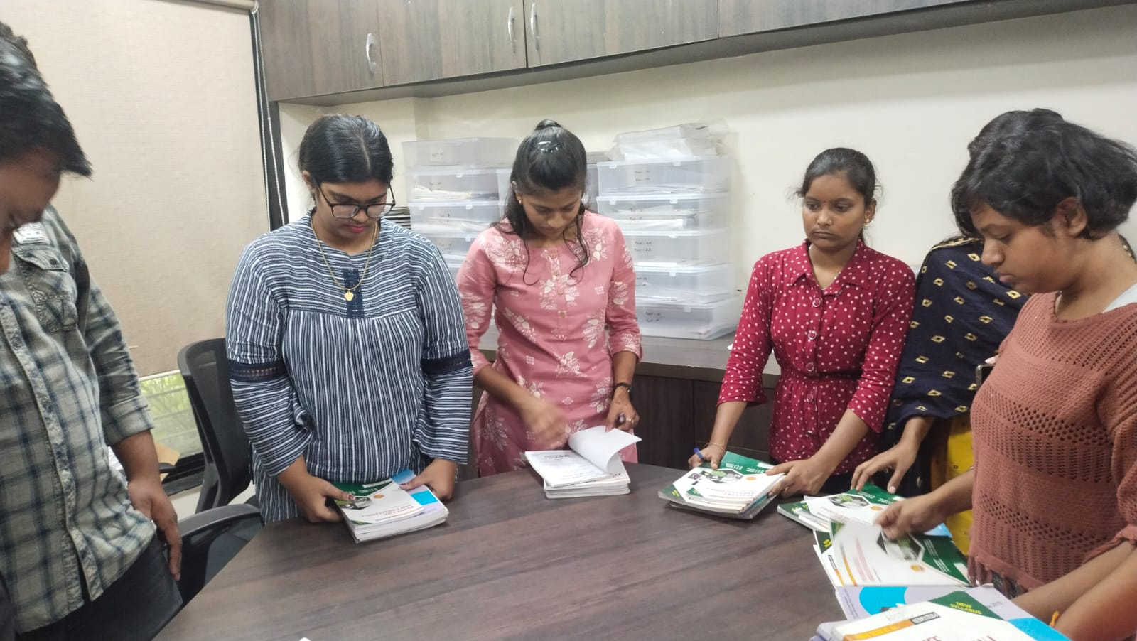
Book bank service provide to students.

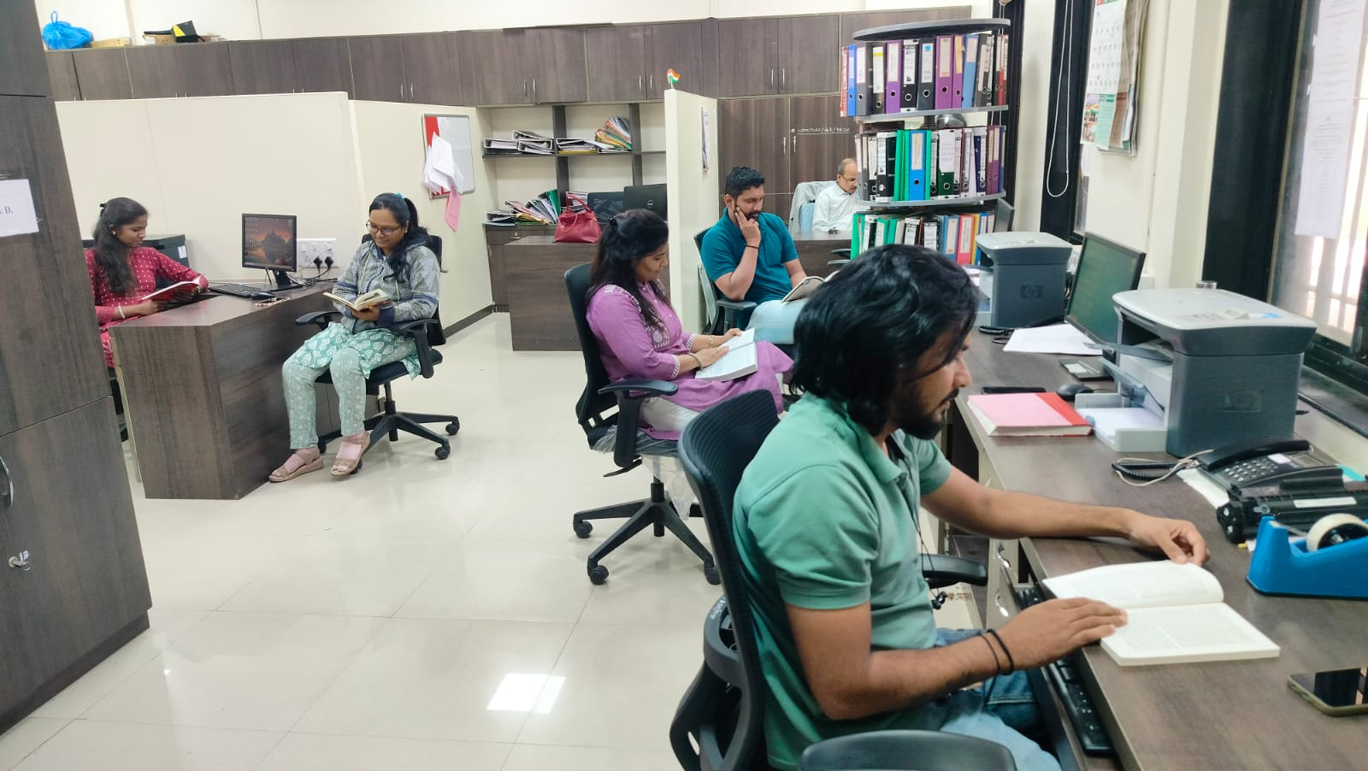
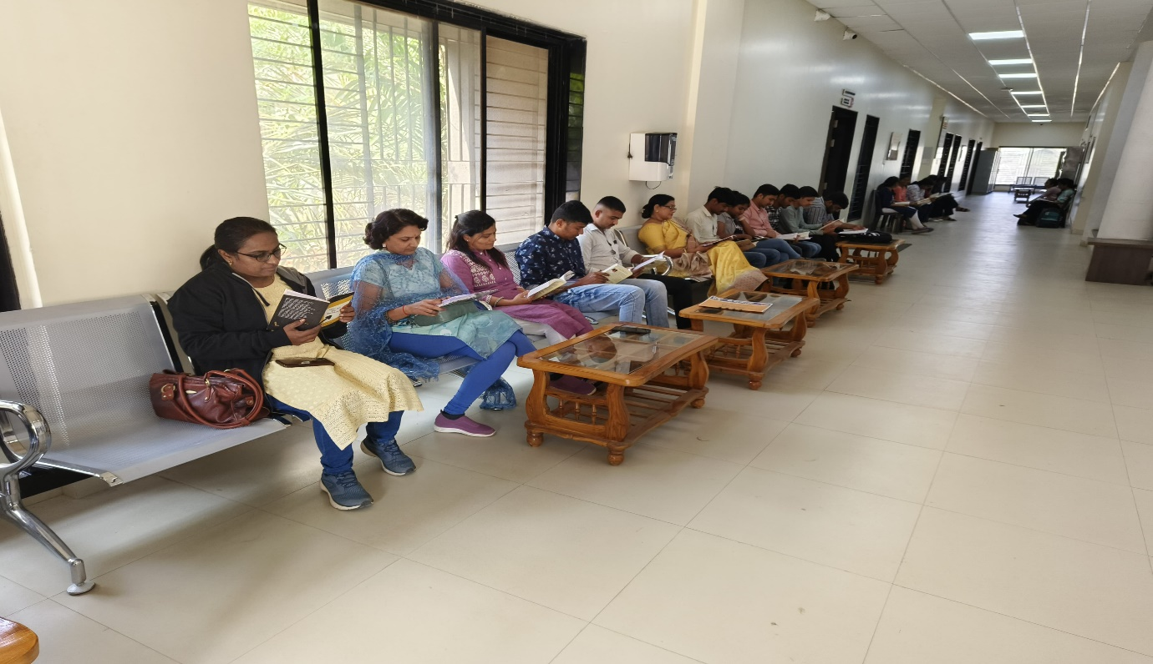
शांतता ! पुणेकर वाचत आहेत…
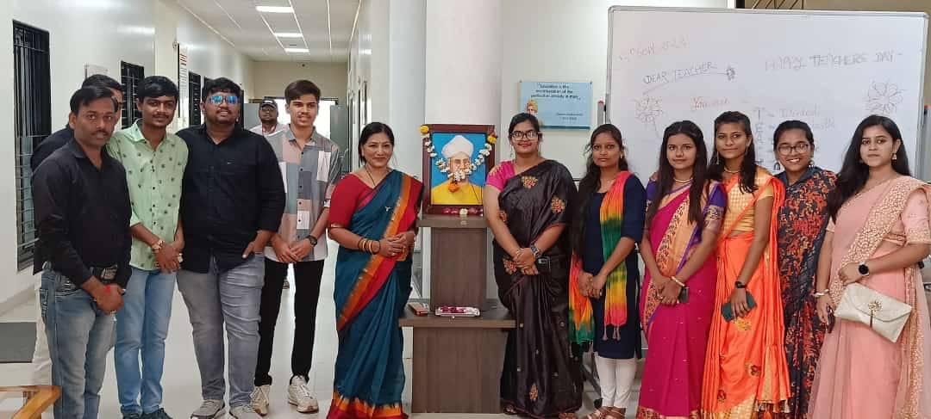

Teacher Day Calibration
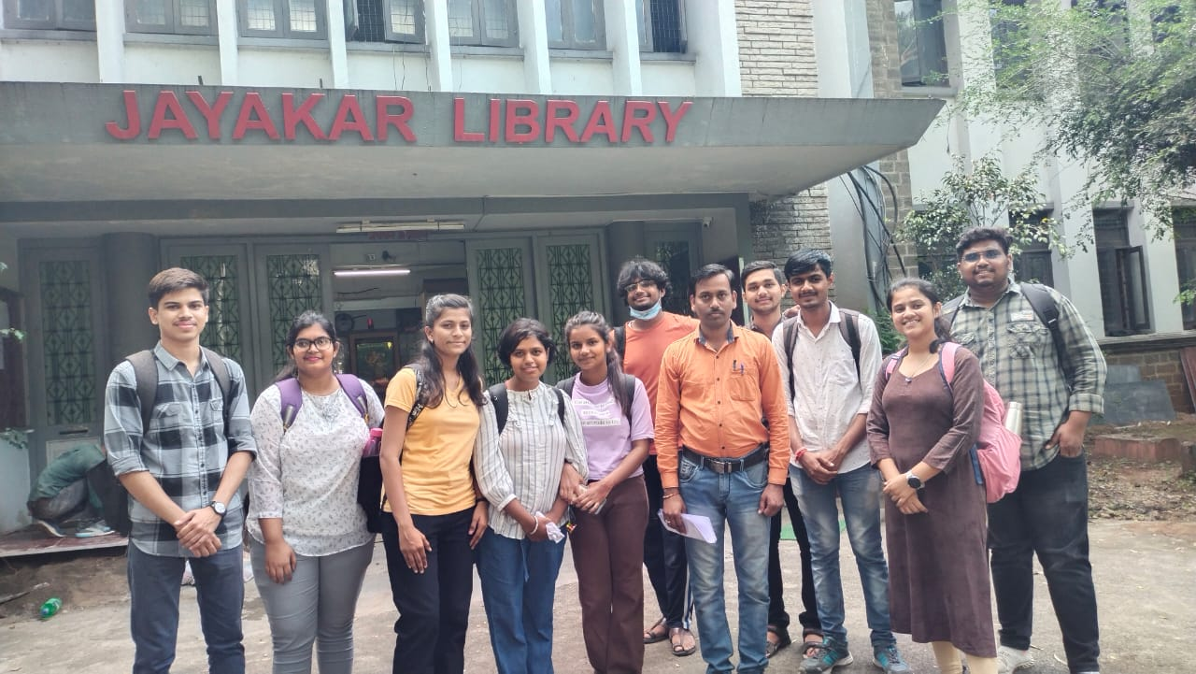

SPPU university main Jaykar Library visit with students.
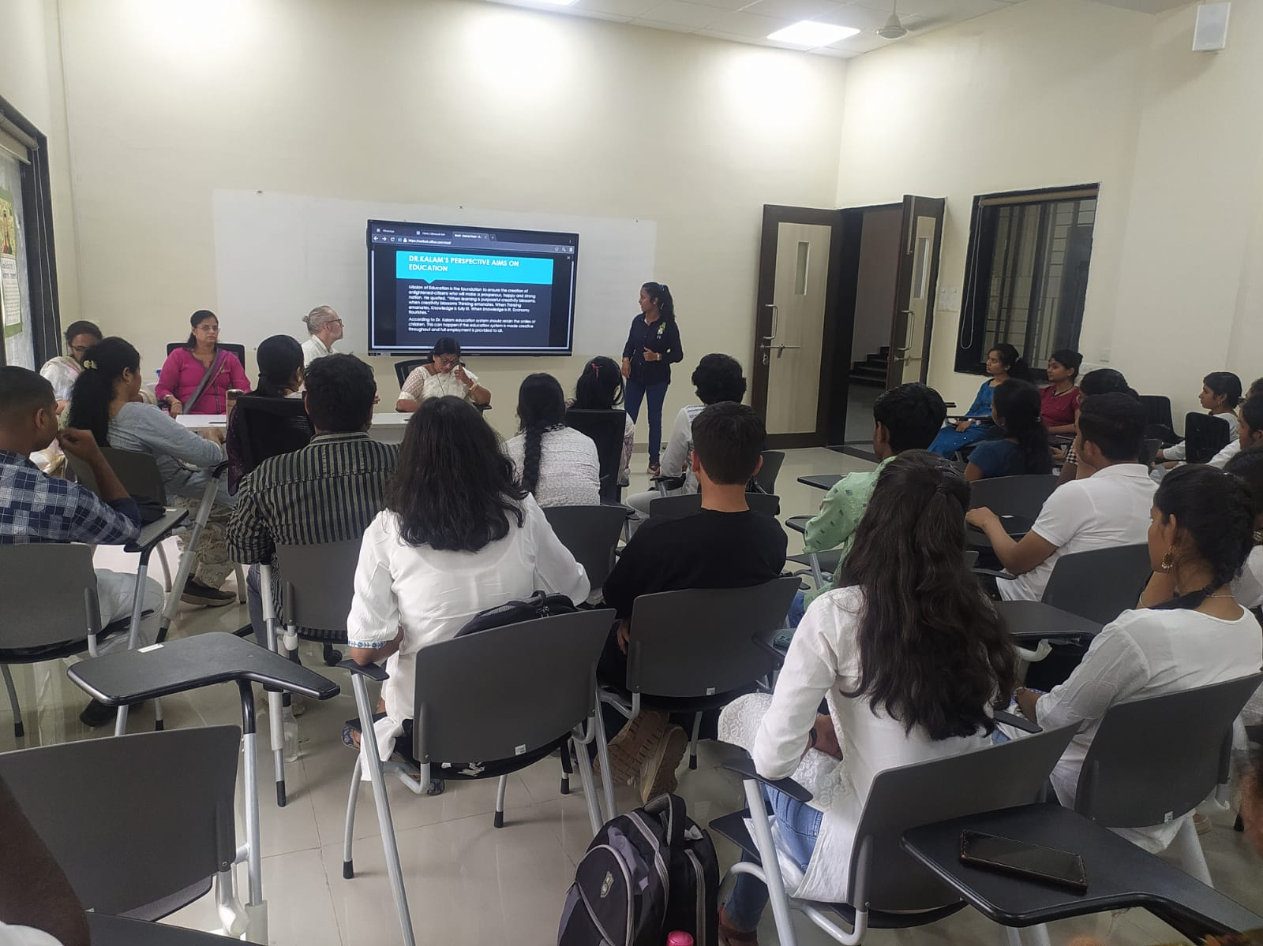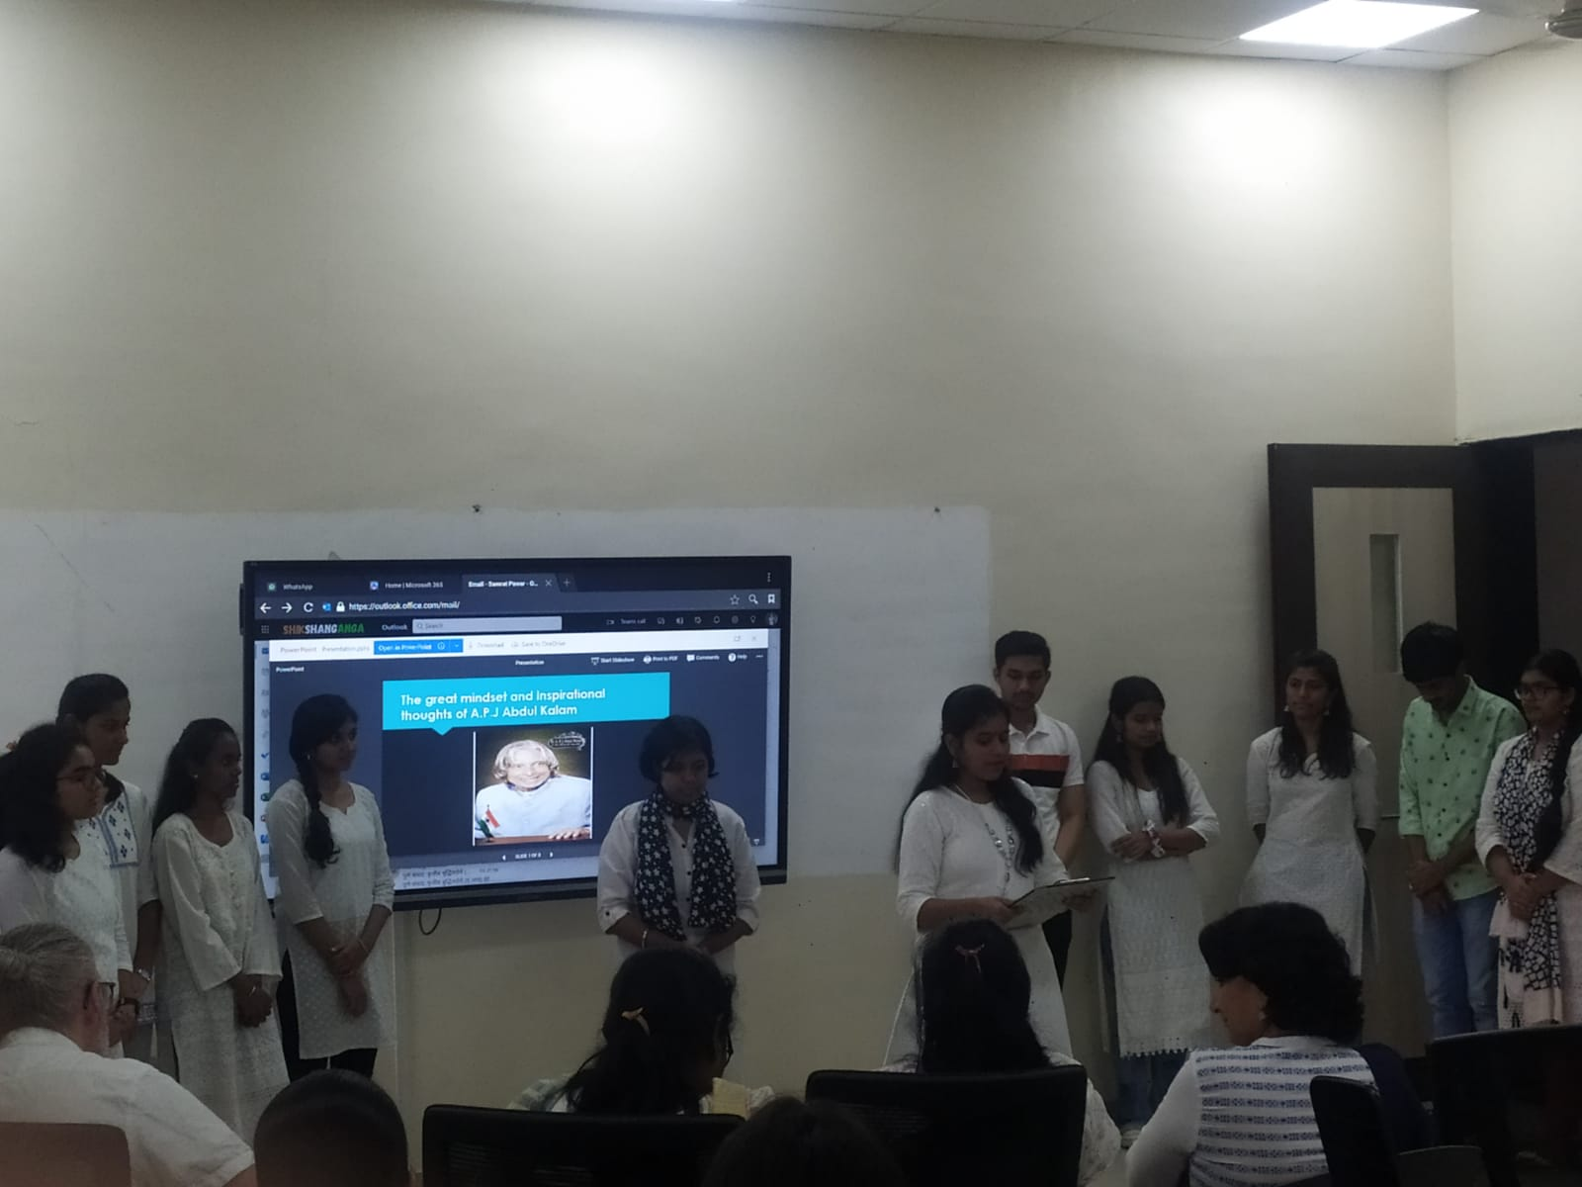
वाचक प्रेरणा दिन…

